**Potassium – Argon Dating**

* Potassium is an element that exists on Earth and is found in rocks. It has the symbol K.
* One isotope (type) of Potassium is very unstable. It is called Potassium-40.
* Potassium-40 (K-40) turns into Argon-40 over time.
* It takes 1.25 billion years for half of the K-40 in the rock to turn into Ar-40.
* We can work out the age of a rock by
  + Measuring the amount of K-40 and Ar-40 in the rock.
  + Calculating the proportion of K-40 remaining.
  + Using a graph to work out the age of the rock.
* This type of dating is **absolute** – it is not an age relative to other fossils or rocks.
* It is able to accurately date samples that are over 200 000 years old.

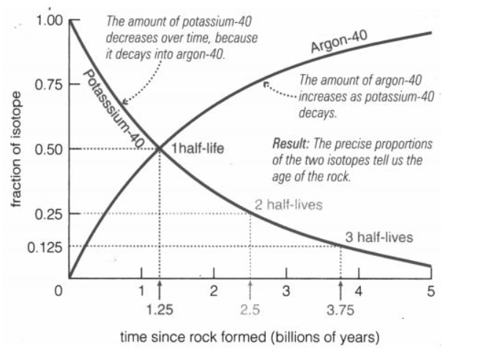

Examples

A fossil is found in rock. The rock immediately surrounding the fossil is analysed and the ratio of K-40 to Ar-40 is found to be 3:1. This means that there are 3 K-40 atoms for every Ar-40 atom.

* What fraction of the K-40 is left in the rock? …………….
* Using the graph above, estimate how long ago the rock formed: ………………………

**Activity:**  
  
You are a palaeontologist, sorting through your fossil collection. In your collection, you find these fossils, still embedded in pieces of the rock they were found in.

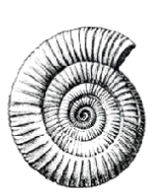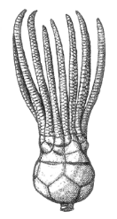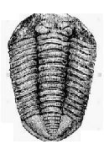

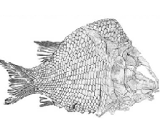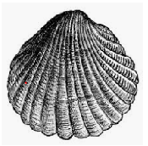

You sample the amounts of K-40 and Ar-40 in the rock surround each fossil. Use the cards given to you, which show the fossil, the surrounding rock, and the K-40 and Ar-40 found in the rock, then fill in the table. You will need to use the provided graph to work out how old the rock is, and therefore how old the fossils are.

|  |  |  |  |  |
| --- | --- | --- | --- | --- |
| Sample | Amount of K-40 | Amount of Ar-40 | Fraction of K-40 | Age of fossil |
|  |  |  |  |  |
|  |  |  |  |  |
|  |  |  |  |  |
|  |  |  |  |  |
|  |  |  |  |  |

Note: Scientists use a zoomed in version of the K-40 / Ar-40 curve in real life, as the vast majority of fossils found are less than 1 billion years old. So they might use only the very top part of the curve.

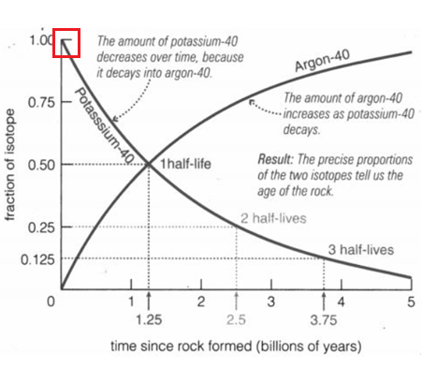

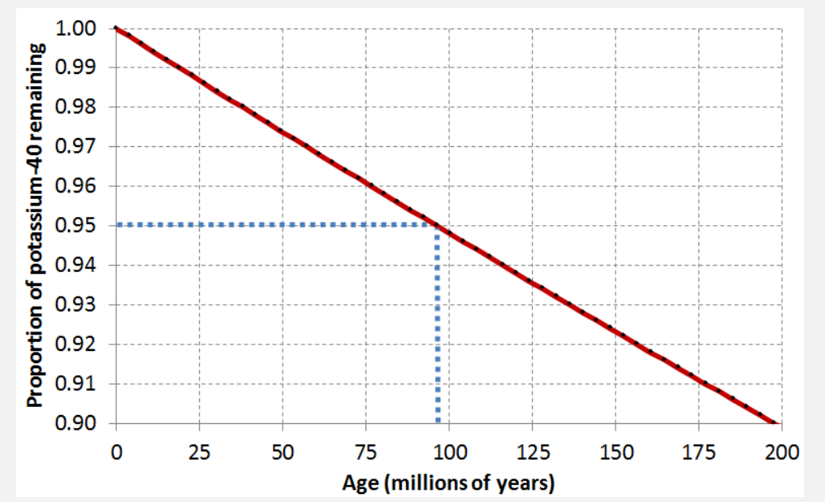

If a sample showed that there were 96 K-40 atoms for every 4 Ar-40 atoms, then the proportion of K-40 remaining would be 0.96 (96%). So the age of the rock surrounding the fossil would be 75 million years old.